Roll.No:241001057Unification and Resolution – Exercises with Solutions

Exercise 1: Sentence Matcher
% Facts sentence(the_cat_sits). sentence(the_dog_runs).
% Query
% ?- sentence(X).
Output:
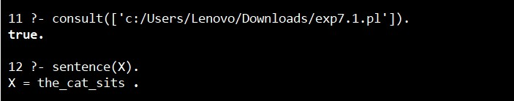

Exercise 2: Compound Term Unification
% Facts likes(john, food(pizza, spicy)). likes(mary, food(pizza, sweet)).
% Query
% ?- likes(john, food(pizza, T)).
Output:
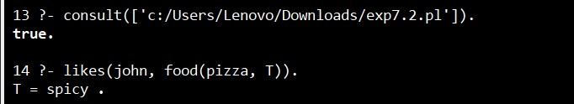

Exercise 3: Conflict Resolution
% Facts rule1(climate_change). rule2(climate_change).
% Rule conflict(X) :- rule1(X), rule2(X).
% Query
% ?- conflict(climate_change).
Output:
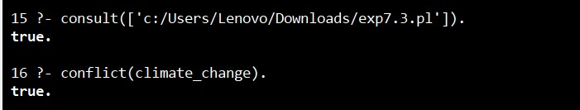

Result
Thus, the Unification and Resolution exercises were successfully executed in PROLOG, and the expected results were obtained.

